**A picture containing clipart

Description generated with very high confidence**

SELENIUM AUTOMATED TEST IN ECLIPSE

DevOps Certification Training

[**support@intellipaat.com**](mailto:support@intellipaat.com)

**+91-7022374614**

**US: 1-800-216-8930(Toll Free)**

**SELENIUM AUTOMATED TEST IN ECLIPSE**

**The agenda of this demonstration:**

1. To open the Intellipaat website,
2. To put a search input (e.g.: DevOps), click on search,
3. In the last search result page find a DevOps Certification Course, click on the course
4. In that last search result page see if the Course Title matches to our Desired Course Title or not, if matches display one message and display the Next Online Class Timings for the Course.

**Step 1:** Before moving ahead let us first add required **Maven Dependencies** in the **pom.xml** file. Also, initialize the web driver. Refer to the Selenium Installation Documentation. Now our **App.java** file should look like this:

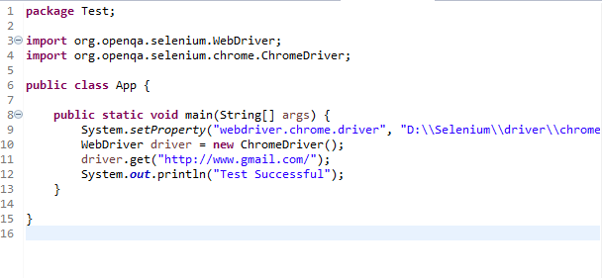

And **pom.xml** file should look like this:

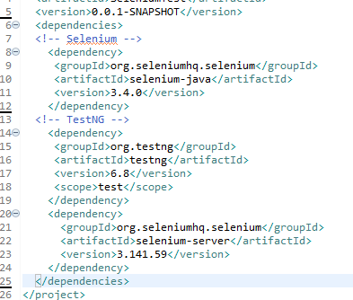

We are all set to start our demonstration,

**Step 2:** Open the Intellipaat website.

driver.get("https://intellipaat.com");

driver.manage().window().maximize();

This command will open the Intellipaat website and then it will maximize the browser window.

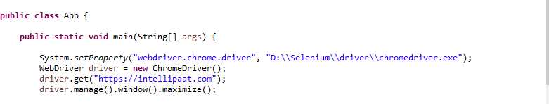

**Step 3:** Import the following before moving ahead.

import java.util.concurrent.TimeUnit;

import org.openqa.selenium.By;

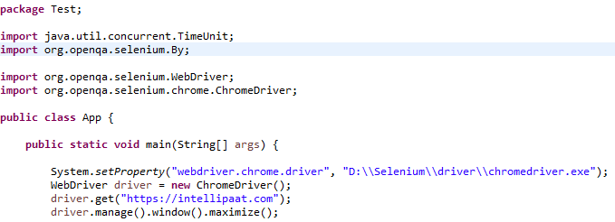

**Step 4:** Now we will find the search input element in the website, inspect the element, find the class name, also find the id of the search click button by inspecting.

driver.findElement(By.className("t-search-input")).sendKeys("DevOps");

driver.findElement(By.id("frontpagesubmitsearch")).click();

driver.manage().timeouts().implicitlyWait(3,TimeUnit.SECONDS);

Here, we have added one time-out of 3 secs.

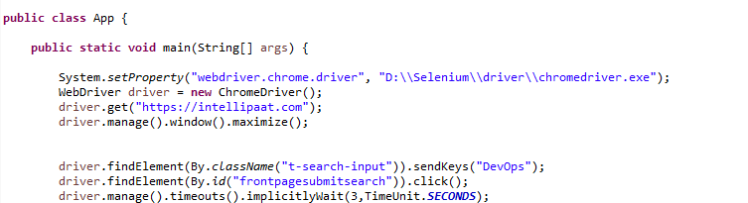

**Step 5:** Now in the last search result page we will find a DevOps Certification Course and click on the course. If course is not found display a “Course not found” message.

String firstData = driver.findElement(By.className("block_title")).getText();

String CheckData = "DevOps Certification Training Course";

if(firstData.equals(CheckData)) {

driver.findElement(By.className("block_media")).click();

driver.manage().timeouts().implicitlyWait(3,TimeUnit.SECONDS);

}

else {

System.out.println("Course not found");

}

It should look like this:

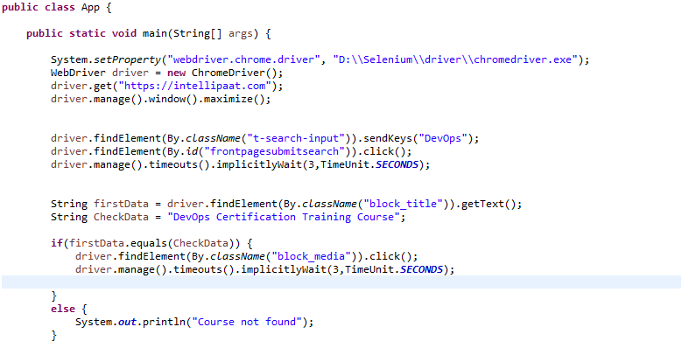

**Step 6:** In that last search result page we will check if the Course Title matches to our Desired Course Title or not, if matches display one message and display the Next Online Class Timings for the Course.

It looks like this: 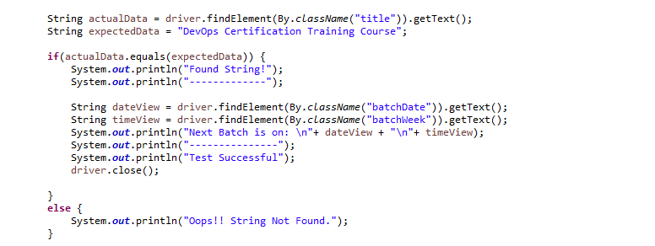

String actualData = driver.findElement(By.className("title")).getText();

String expectedData = "DevOps Certification Training Course";

if(actualData.equals(expectedData)) {

System.out.println("Found String!");

String dateView = driver.findElement(By.className("batchDate")).getText();

String timeView = driver.findElement(By.className("batchWeek")).getText();

System.out.println("Next Batch is on: \n"+ dateView + "\n"+ timeView);

System.out.println("Test Successful");

driver.close();

}

else {

System.out.println("Oops!! String Not Found.");

}

**Step 7:** Now run the program. A Chrome browser window will pop up. See the results as shown below:

First, opens Intellipaat website window.

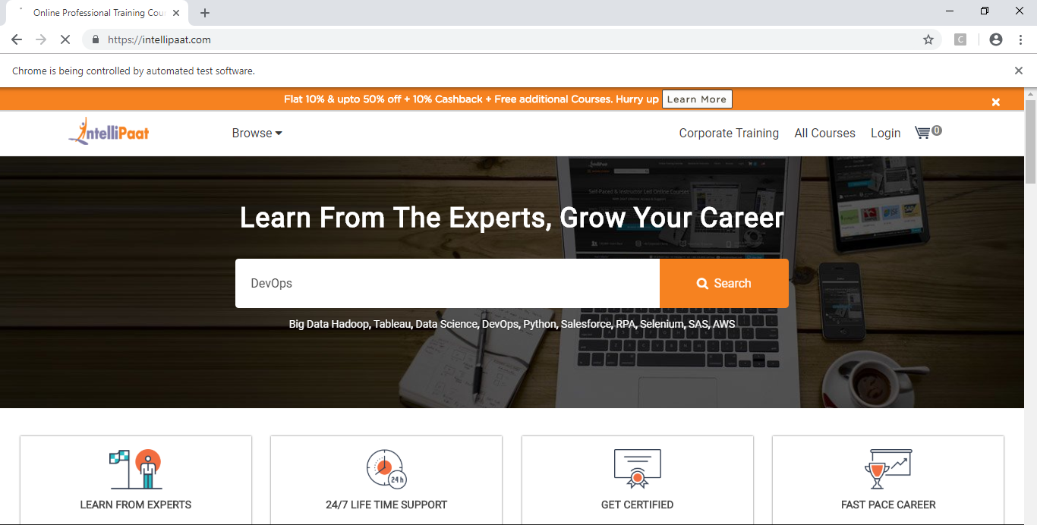

Then clicks on the DevOps Certification Course.

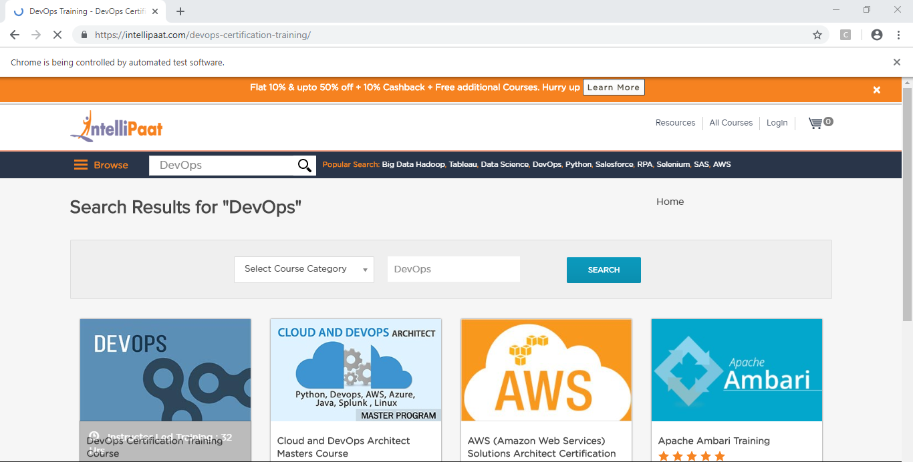

Finally lands on the course page. And then window gets closed.

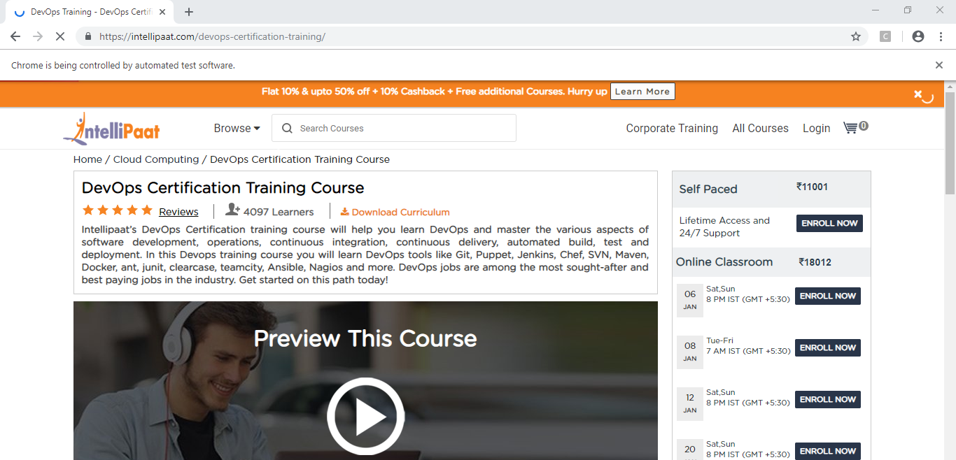

**Step 8:** Now see the eclipse console. It should display our **Next Online Classroom Timing** as shown below.

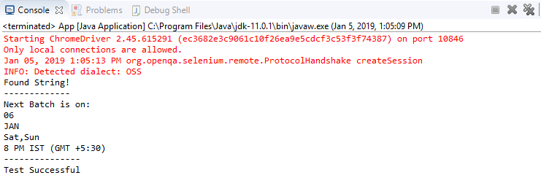

**Congratulations**! You have successfully completed your first **Selenium Automated Test.**